**Lab 5**

**Introduction to C Programming**

Marks: 8

**Question 01:**

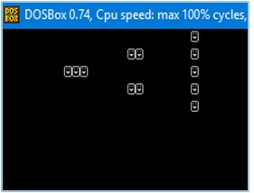Generate the following output. (hint: ASCII value of ☺ is 1)

**Question 02:**

Use arithmetic operators to write the following expression.



**Question 03:**

Write a program to display the size of different data types on different lines in the order of increasing data size.

**Question 04:**

Write a C program to input marks of five subjects Physics, Chemistry, Biology, Mathematics and Computer. Calculate marks obtained and percentage of that student.

**Question 05:**

1. Write a program that asks user for temperature in Celsius and convert it into Fahrenheit.
2. Write a program that asks user for temperature in Fahrenheit and convert it into Celsius.

(Hint: use °C  x  9/5 + 32 = °F and vice versa)

(Note: There should be only 3 digits after the decimal point if output contains a fractional value)

**Question 06:**

Write down the following programs, display the output, if there is an error in program then correct it.

* 1. Void main ( ) { Int I ; I=0x10+ 010+10; Printf (“\nx=%x”, i); }
  2. Void main ( )

{ Printf (“\n ABC\b\b\bInfo World”); }

* 1. void main ( ) { printf(“%d”,’B’ < ‘A’ ); }
  2. main()

{ int x , y ; x = 753; y = 722; printf(“ x & y is %@” , x & y ); }

* 1. main()

{ int x , y; x = 2003; x++; y = x++; y = x; y++; x—; x— printf (“%d%d”,x,y);

**Question 07:**

Raza was not feeling well; he went to the doctor. Doctor check Raza and prescribe him 3 tablets in the morning, 5 tablets in the afternoon and 3 tablets at night. Based on the input find out the total number of tablets Raza takes in a day.

**Question 08:**

Write a program that asks user to give number of days as input and returns the number of years, weeks, and days.